<Insert Name> Community Sponsorship Group
About <area> name
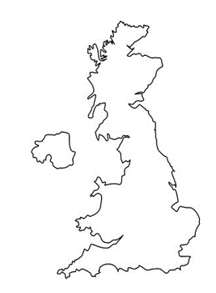
Insert photograph that is indicative of your area
Introduction about your Group:
- Welcome to the family
- Who your Group are (friends/neighbours/how you know one another) – don’t forget to mention you are volunteers
- Outline of what you have been doing to prepare to welcome the family

Insert Photograph of your Community Sponsorship Group here

Use arrow to indicate location
Describe the location (coastal town? Large city? Market town?)
Distance from nearest large town/city
What is in the local area
Describe transport networks
Is there a community in your town of the same nationality/speak the same language as the family you support

Insert photographs of the property – exterior and interior to give an idea of what it is like. Introduce what the property is (flat, house etc, number of bedrooms)

- A note of welcome from your Group
About your support
Outline who will be meeting the family at the airport (include photographs if possible)
How long journey from airport will be to property and how this journey will be taken
Indicate if internet connection will be provided
Outline what the first few days will be like – key things you will be doing – registering for benefits, signing tenancy agreements, registering with Doctors, Schools and banks

About the location of the property
- Include information about nearby schools, shops and places of worship, healthcare providers and English language classes
- Be clear if something is not nearby but how you can support the family to access this (e.g. bus ride to nearest Middle Eastern shops)

