<group logo and or name>

Contact details
Group Name:
Email:
Phone:

Who are we?
We are <insert name of CS group>. We are very much looking forward to meeting you!
We are made up of volunteers who have been approved by the government to resettle a family. Volunteering means that we are not paid to support you, but we have chosen to do so because we want to resettle your family to our area. We have fundraised money to furnish your home, paid for interpreters and found you accommodation for the first two years that you are in the UK. We will help your family claim benefits from the government which will include the money to pay your rent, <enrol your children in school>, access healthcare, get to know your local area and prepare you to eventually look for work. When you arrive, the first few days and weeks will be very busy but over time we hope you will feel part of our community.
Here are some of the volunteers who will be supporting you <insert group photo. This could be a screenshot of a Teams/Zoom meeting if you don’t have a group photo>

Contact us
We would love to speak with you before you arrive. If you would also like to, please contact us using the details above. We will arrange for interpreters to be present during our communications. We are happy to be contacted via email or phone. If contacting us via phone please message us first so we can arrange for an interpreter to assist us.

Where are you moving to?
<area> is a rural/urban town/village/city in <country>. The red arrow on the map below indicates where you will be moving to. If you would like to research the area more, the postcode of your new home is <only the first half of the postcode i.e SW1, NW1, BN2.>
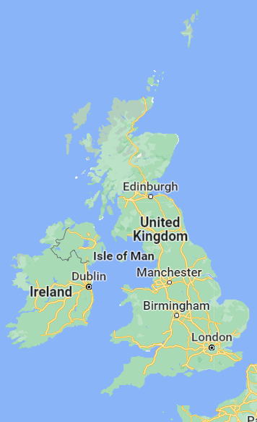

<Insert photo indicative of your area>

Distance from your new home
 | Walking (in minutes/hours) | Public Transport (in minutes/hours)
Supermarket | e.g 10 minutes | e.g 5 minutes
School
ESOL lessons | Indicate if the classes will take place in the home
Mosque/Place of worship
Halal butchers
Nearest city/large town

Your new home (insert pictures)

